Brief: In Game Fps Counter

When testing the game, the fps with be shown on the top left of the screen. It will update the number in every frame. This can be seen when the test player is moving around.

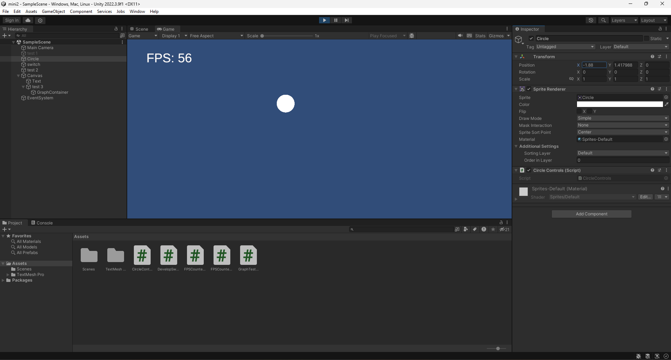

To turn off the counter just press the space key and to turn on the counter just press the p key.

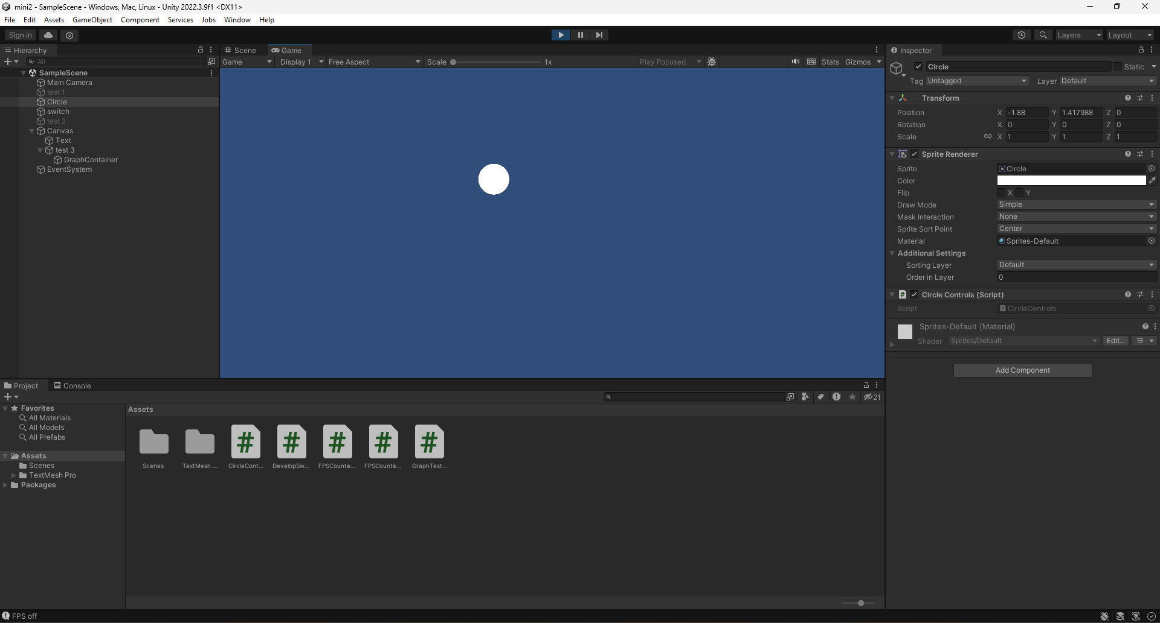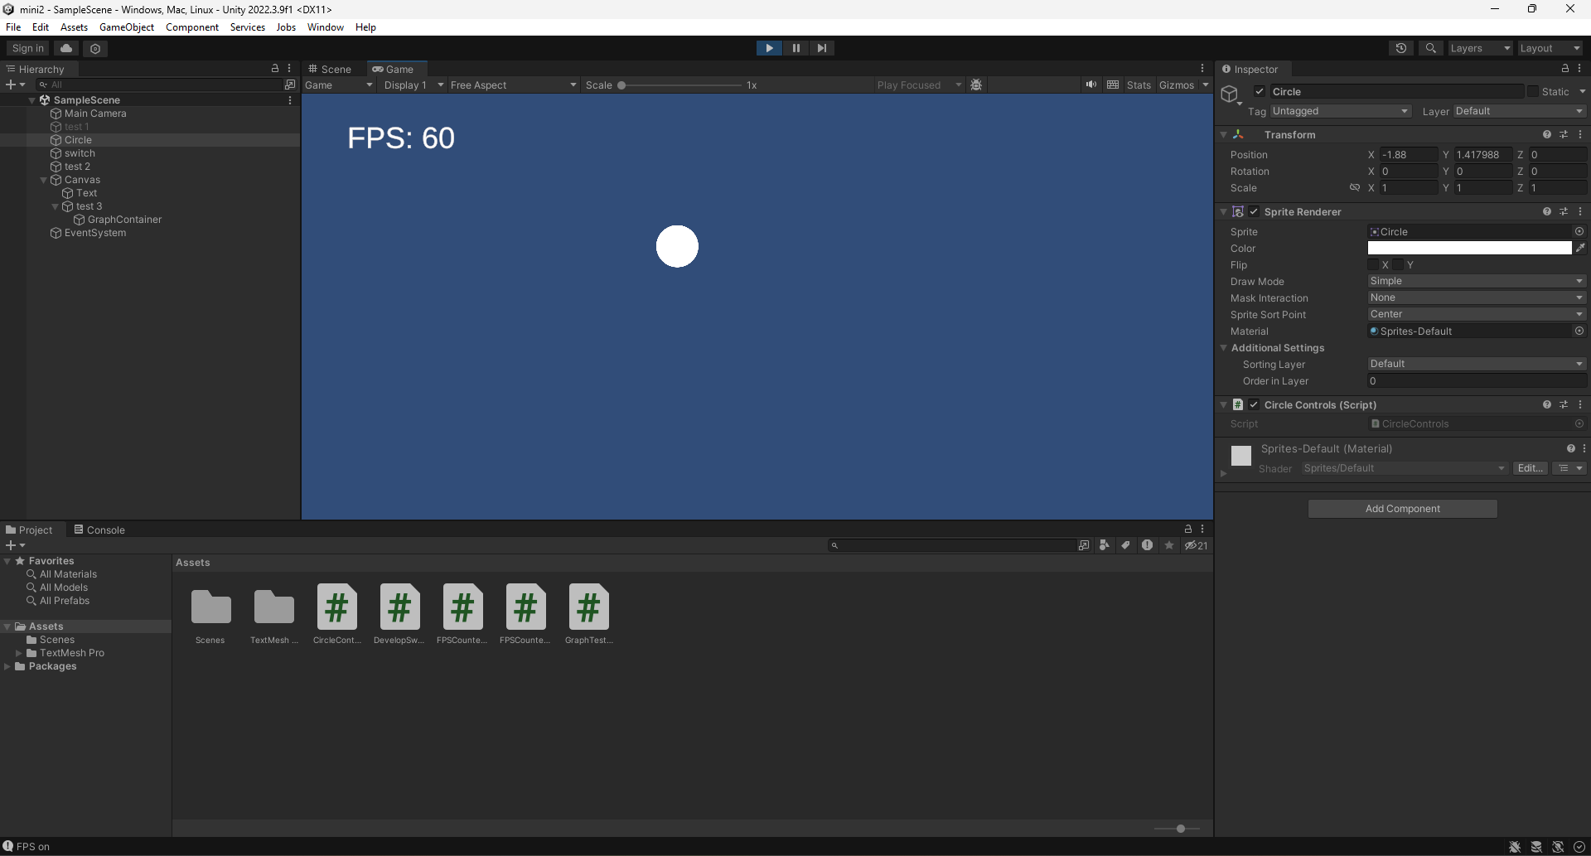

Scripts:

The first script is used to show the game's fps in a text object on the UI. The script first limits the fps to 60 frames per second because then the numbers would be about a thousand or near.

After the fps is limited, the script starts to calculate when the number of shows the number of frames in each second so it can be readable while testing the game. This is done by having the float be minus the delta time. Once the float is equal to zero or less then it will calculate the fps and have it rounded to a full number so it can show in the game. the float is then reset back to 0.2. All this code is part of a function which is then attached to the update function, so it is updated every time the game object to which the script is attached is active.

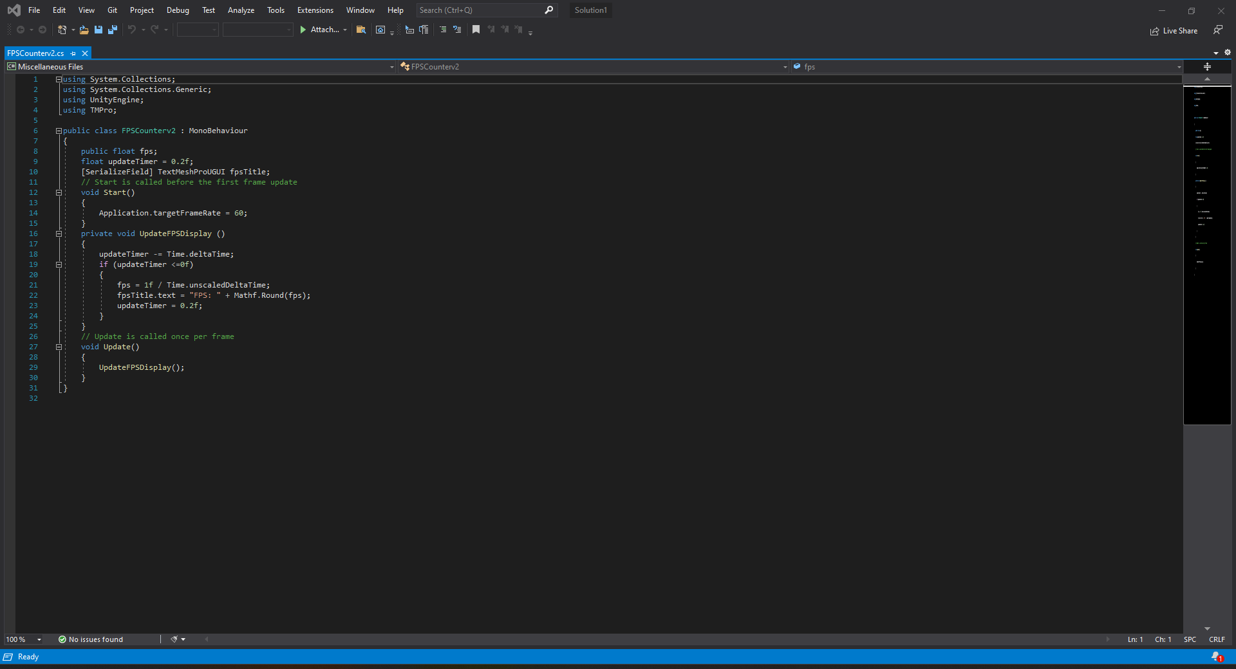

The other script is used to turn on or off the game object which has the fps counter script.

The script is simple as it has both the game object and the text game object attached to the script, so it lets them be controlled. The script has when I press the p key it will turn on both the text and the game object allowing for the fps script to function. If the space key is pressed, then both game objects will be turned off. The debug text is only to see if the script worked properly.

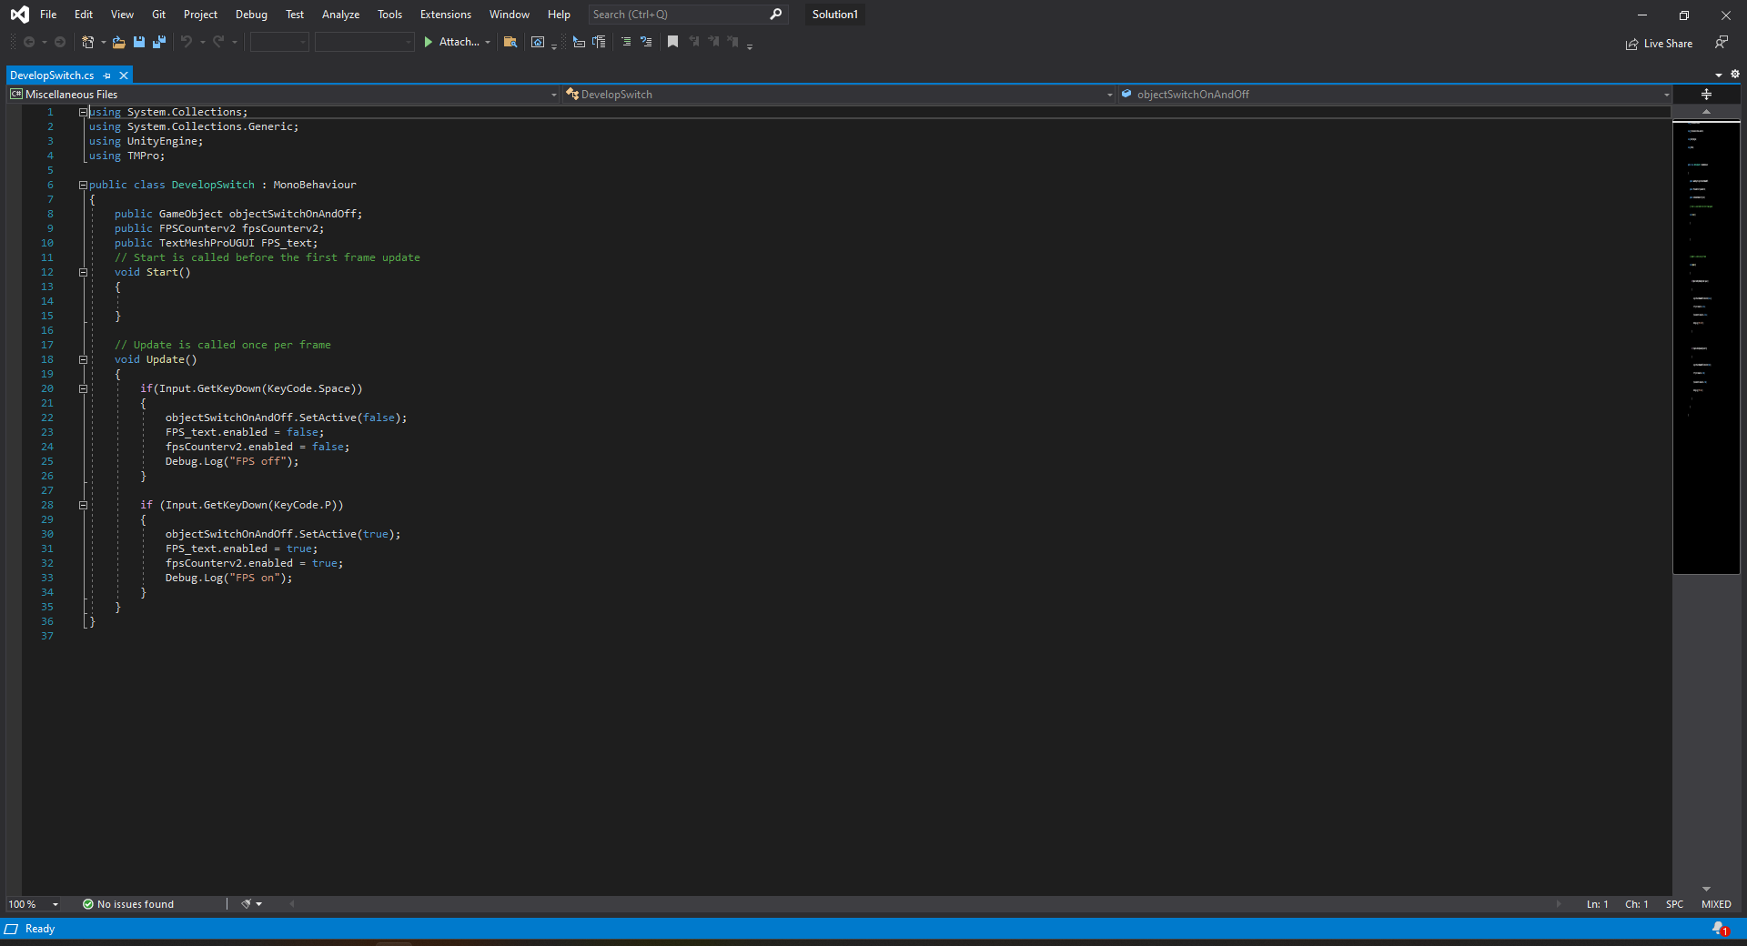

Brief: speedometer

When testing the game, the speedometer needle will start on the right. When rotating the ground object around to move the player the needle will start to move to the left as the numbers get bigger.

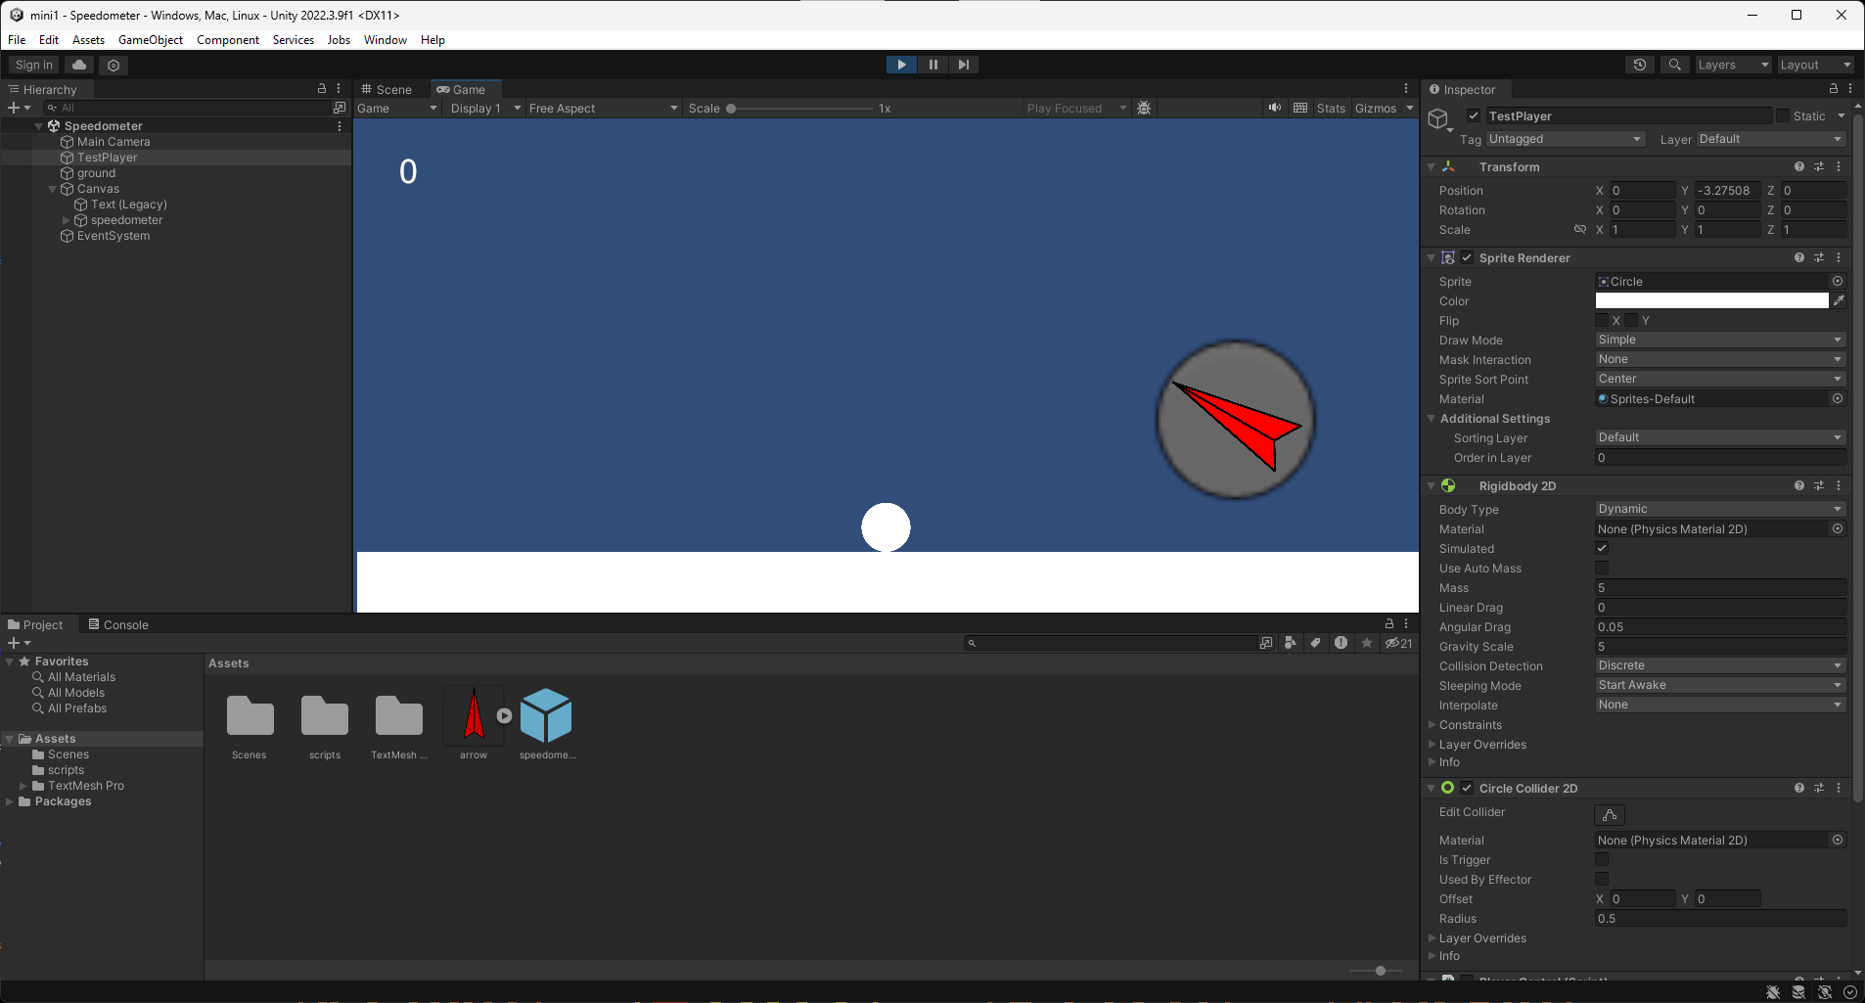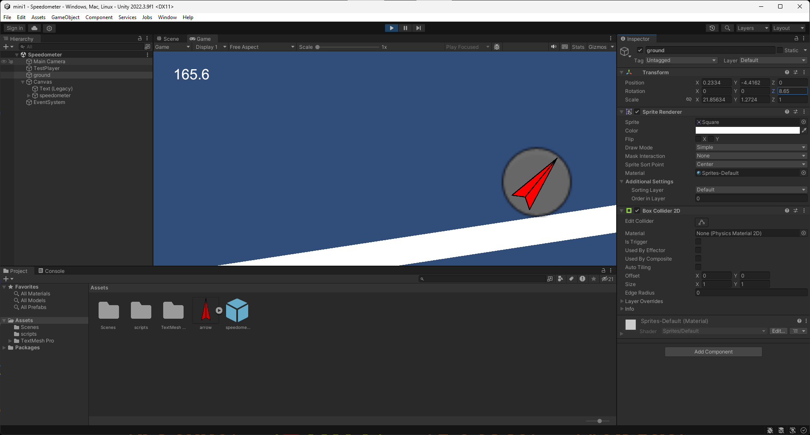

Scripts:

The script first has the players ridgidbody connected to it and call for it at the start of the script. When the script awakes, there are two floats used in other parts of the script.

When it is constantly updating, the script uses the player's ridgedbody to calculate the speed of the player which is then converted to miles per hour by other calculations. Those results are then used to calculate the needles rotation. There are two floats which are used to determine the point where the needle rests when the player is not moving or where the max point is, so the needle does not keep rotating around and just stops.

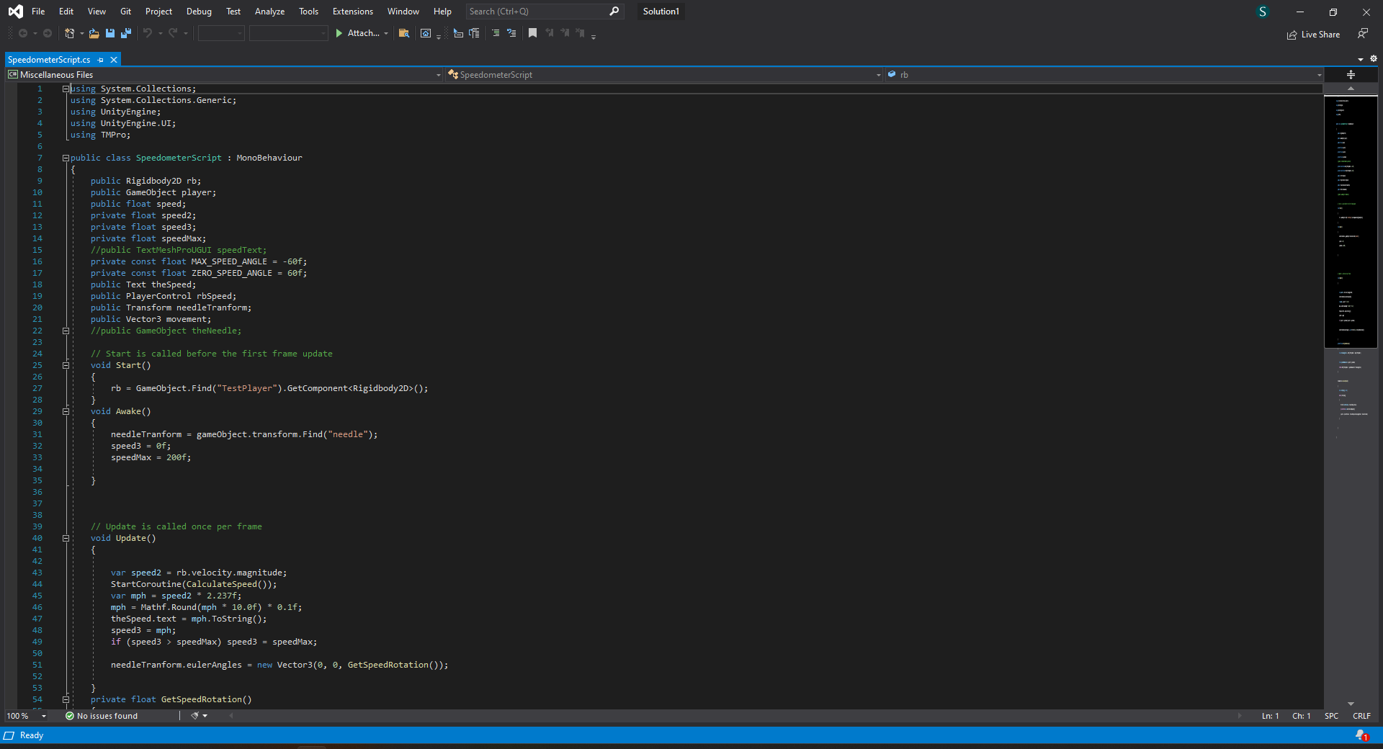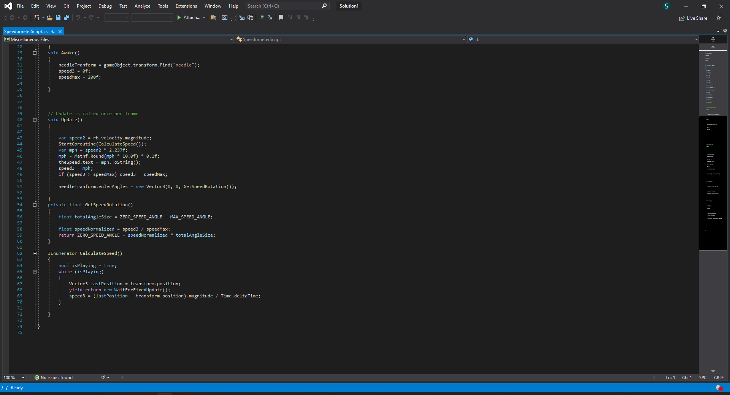

Brief: shuffle

When testing the scripts, the player can edit the list in the game object isnpector that is used to test the function containing the main code. The name in the list can be anything as in the brief it said I was going to be given a list of strings of music names. When the space bar is pressed the list will be shuffled and show on the text object. If the list somehow is in an identical order to the previous list, then it will be indicated by a text on the console.

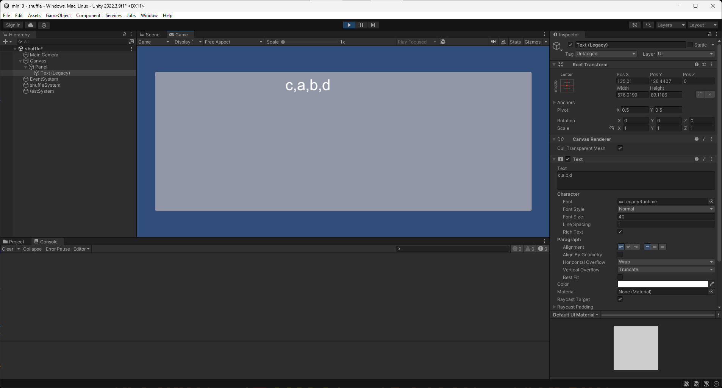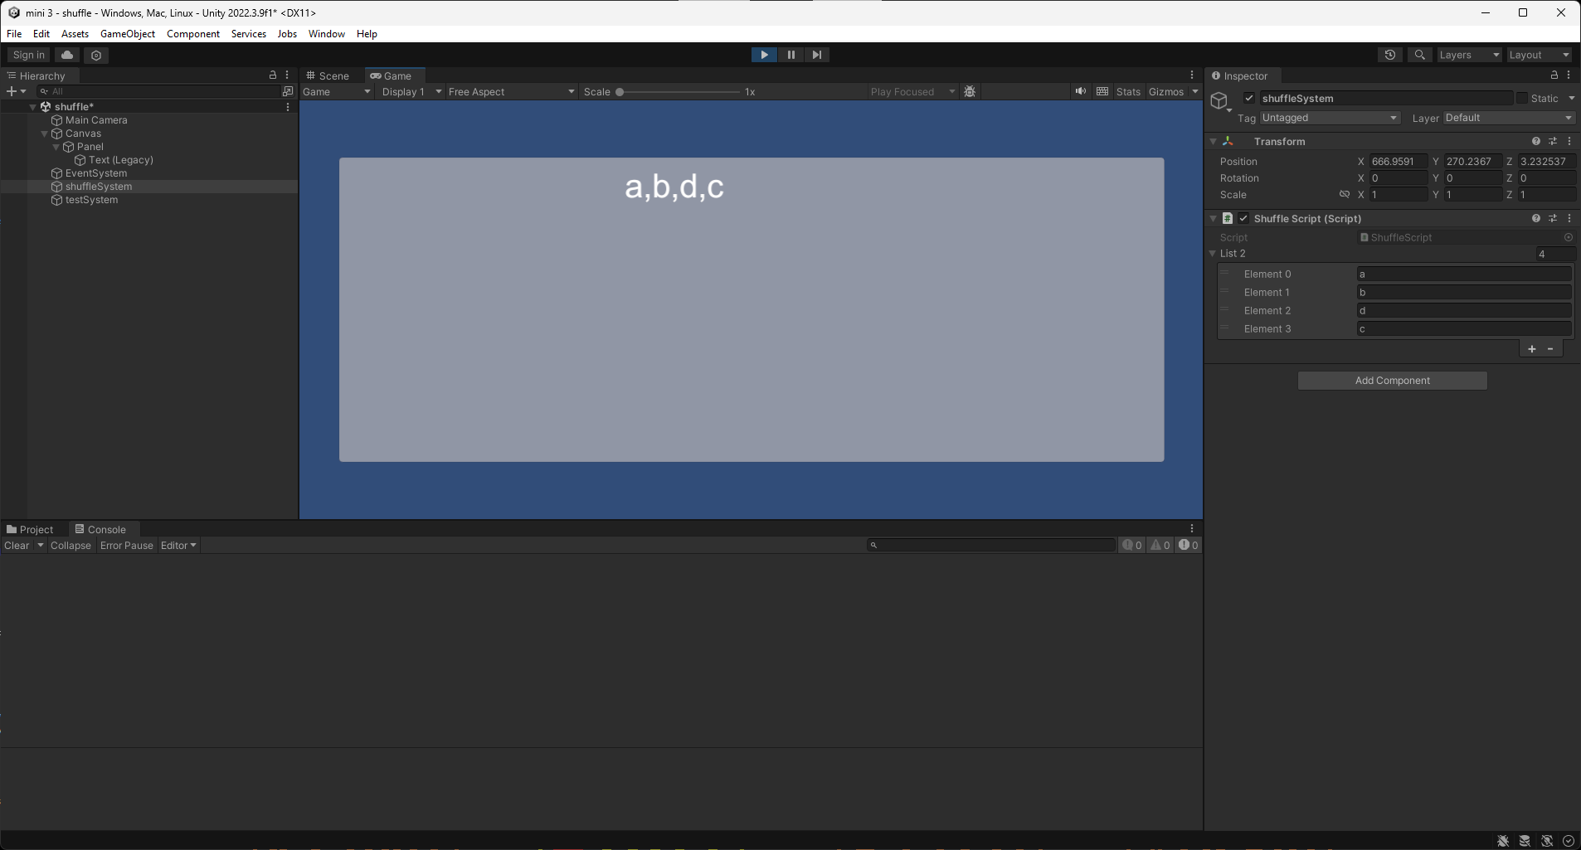

Scripts:

The two scripts work together to make everything work. The shuffle script first sends the list which the test script has.

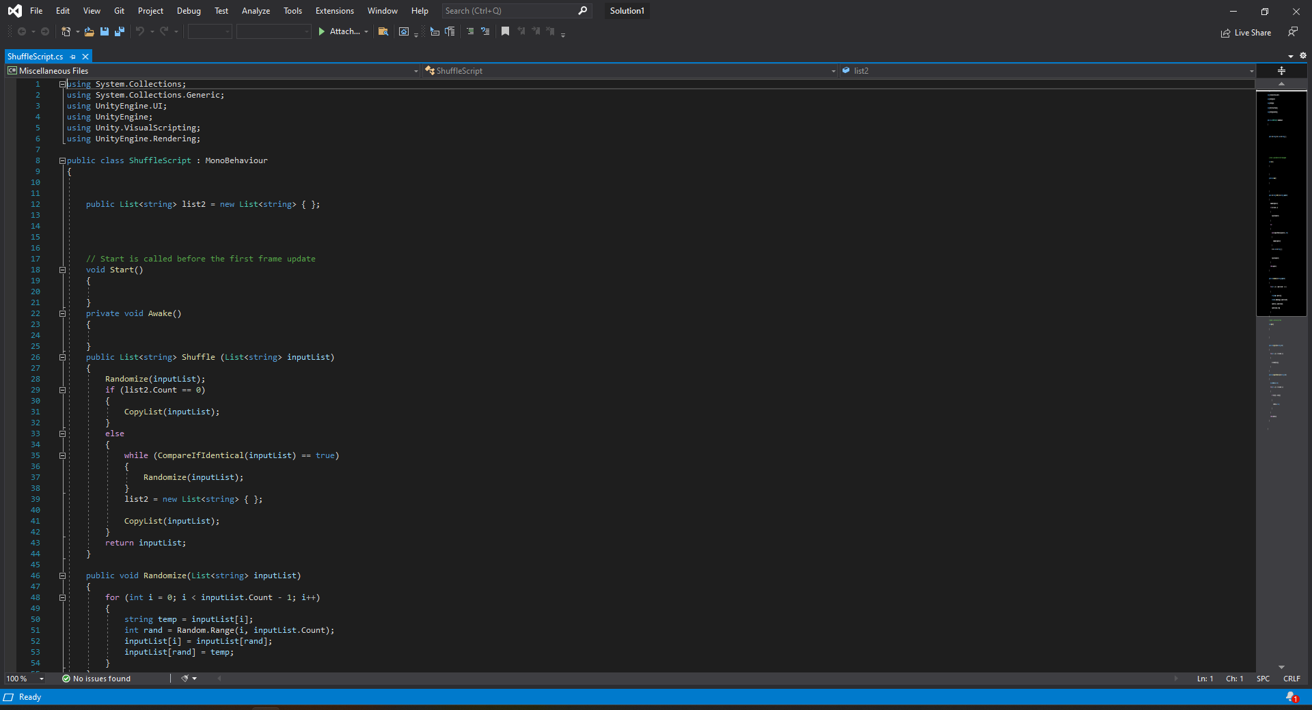

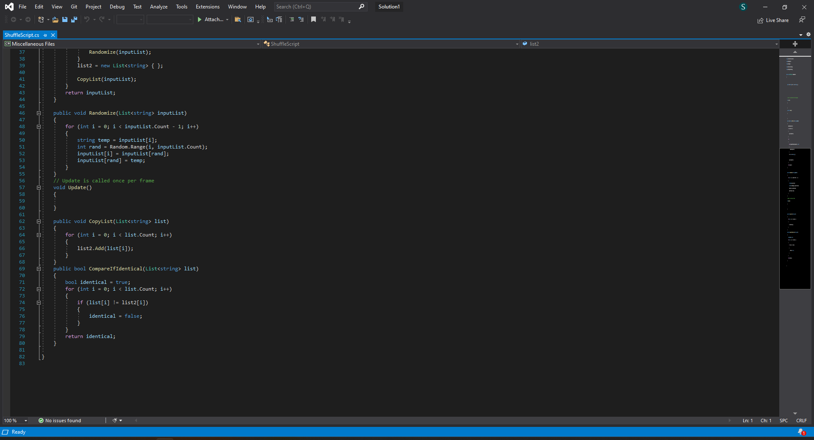

Once it has the script it will make a copy of the first and put it on the second list before shuffling the first list. When the list is shuffled again the script does the same thing again with the second list. After that it checks both lists to see if they are identical or not. If they are then the first list is shuffled again until they are not identical. All of this is done in different methods to keep it organized.

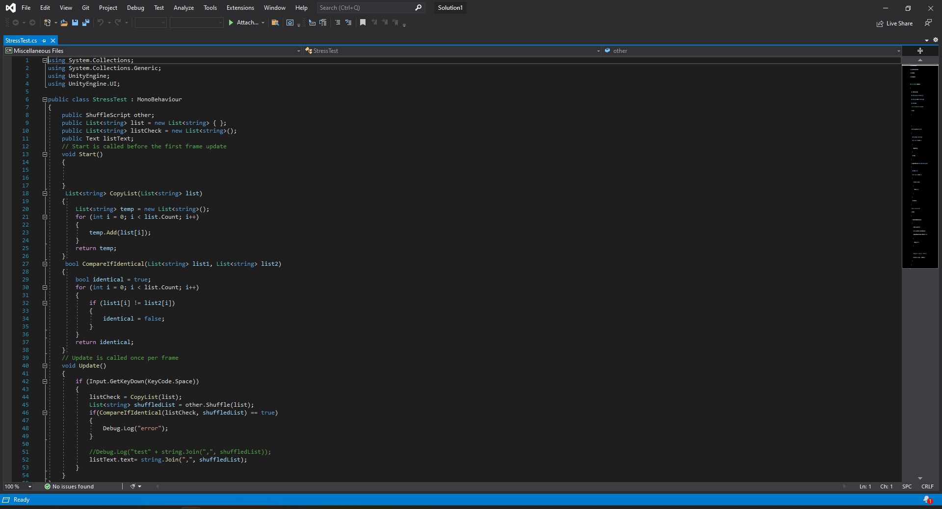

One the script was shuffled its send back to the test script. The test script also copies the list before its send to the shuffle script. The script does the same thing the shuffle script did but if they are identical then it will send a message to the console. When the test script receives the script, it will use the attached text object to show the names in the order it was shuffled.

**Reflection:**

The first brief I did was the fps counter. This brief was one of the easy briefs that I could pick. It was an ok brief even if I only did the basics and not the extra credit part of it. The fps was easy to get done as I only needed to show the fps in each second like I was told on the brief as they wanted it not to be too fast and easy to see. The part I needed to have so the fps cannot be seen in normal gameplay was done by having two buttons which either turn on or off the object which had the fps attached.

Even if it were okay, things could have been done better. One of those things would be managing my time so I could have made the graph which was part of the extra credit. There were also many problems with the scripting of the fps counter. I had to restart the whole script once and use a different method of code to get it to work. The other code was just not easy to understand and was just broken. However, I was able to get a better version using the code of the script. But from this, I have learned many things which I can use in the future when making my games and other projects or improving so I do not have to make the same mistakes again. For example, planning my time better so I do not have to worry about getting the brief done before I start the next two.

The second brief was a bit worse compared to the first one when it comes to my experience doing it, but it ended up ok in my opinion. This brief was also an easy one when picking my options of brief like the first brief I did. I also did the basics of what I needed to from it like having a speedometer, having it use the player's ridgidbody and convert it into miles per hour so it can be used to rotate the speedometer needle from one side to the as the numbers increase or decrease.

There were some problems when making the brief like getting everything working correctly as there were many errors and things that did not work at first. For example, the needle does not rotate and just stays in one place or just rotates to the right and not moving when the player is moving around. Another was when the players' ridgidbody did not stay attached to the speedometer when testing the game and had to be added by dragging it to the inspector, and many others. However, I was able to get those issues fixed before finishing the project. The documentation was simple since I only had a little time left and since there were not a lot of things to talk about. But with all this, I did learn something that I can improve or use in the future like managing my time better, so I do not have to worry about finishing everything before starting my next brief.

The third brief was complicated until the end as the last one I did. When picking this brief, I decided to try one more difficult compared to the other two briefs which were small and a bit easier to get done. The code and everything else ended up ok and working and that is how they asked in the brie. This brief was more stressful than the other two as I struggled to get a script working correctly or to do what I wanted to do correctly. But in the end, I was able to get it finished and in good condition.

There were some problems which I had to fix or try to understand. For example, the part of the script which was used to check to see if one list was I same as another after it was shuffled. That part took me the longest to get fixed and working but, in the end, I was able to get it done and use something similar for other parts of the other script needed. I did have help when making this brief but since this was harder than the other two, in the end, it was ok.

I have learned a lot by making the code for this brief. I learned how to use and code things like lists and making a shuffling function, and having them work in unity, how methods and functions work to make the code work and more organized and many other things. But in the future, I hope to use what I have learned from this, so I do not make the same mistakes and stress more. One of these would be to ask for help more often from people who have more experience in coding, as I could learn more and make my work better in the end. In addition, like with the other two briefs, I should organize my time for the work better to have a better time working on the brief.

All three briefs ended ok with a few problems and issues throughout my time working on them. I did learn a lot and improved my skills in coding but there is a lot that I still need to improve and learn. One of those things would be managing my time. This is because while doing the briefs I have not been working a good amount of time that could have been used to get everything corrected or in a better condition.

The documentation for all three of them is simple and not too detailed as it was written near the end of each brief. But they explain the scripts and how the code works well enough to be understood. Overall, I think I did ok on these 3 briefs but next time in the future I should improve myself on both outside and inside of on working on the briefs

Links:

[package](https://stulsbuac-my.sharepoint.com/:f:/g/personal/s4210507_lsbu_ac_uk/EgcmAPzKVNVKm5OppxzrFUcBu0NU_NrCebLUnohpQhZb4w?e=nvpFsn)